**COURSE TITLE:** IFT 598:Data/Visualization/Report/IT-M-W (2022 Spring)

**ASSIGNMENT TITLE:** Project - Phase II: Decision Making

**INSTRUCTOR NAME:** Asmaa Elbadrway

**TEAM MEMBERS :**

**(Team -10)**

Soma Sai Rahul Muddamsetti

Sharanya Pendyala

Likhitha Thalakanti

**Section 1: The Dashboard**

[**https://public.tableau.com/views/Team10Dashboard_IFT598/Team10Dashboard_IFT598?:language=en-US&:display_count=n&:origin=viz_share_link**](https://public.tableau.com/views/Team10Dashboard_IFT598/Team10Dashboard_IFT598?:language=en-US&:display_count=n&:origin=viz_share_link)

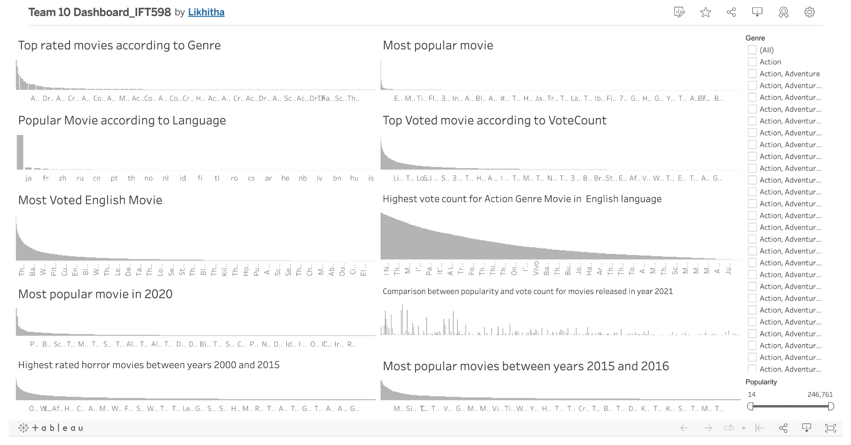

We have created the above dashboard to display the 9000 movie dataset into various plots. The dashboard contains 10 plots which represents comparison between rows and columns of dataset using plot called bar chart .We have used some preattentive attributes, controls and filters in this dashboard to make it interactive, color as preattentive attribute, genre as filter and popularity as a control where user can slide it and can view required outputs. In order to make it attractive we have maximized the data ink ratio by removing the y-axis for some of the plots other than that we have removed the grid lines and rotated the labels in x-axis. In addition, in order to impress the user we have only used one color (gray) so that the user will not be in a skeptical state when the user visits the dashboard.

Each of the plots depicts the questions mentioned and each individual depicts different scenarios to search for a particular movie or popular movie based on the filters and controls. We have added filters to make it interactive.

**Section 2: The Dataset**

The dataset that is being used here is Kaggle dataset-9000-movies-dataset. This dataset is created to build a movie recommender system using Natural Language Processing and Machine Learning models. Dataset has 9 columns and 9827 rows , the columns having the following contents : Release_Date, Title, Overview, Popularity, Vote_Count, Vote_Average, Original_Language, Genre, Poster_Url and the rows have contents about these columns.

Attributes in Dataset :

Release Date

DATA TYPE : Interval

DOMAIN : Varies from 4/17/1902 to 7/3/2024 along with various reasons

EXPLANATION : This column contains the release date for the movie

Movie Title

DATA TYPE : Categorical

DOMAIN : Different movie names

EXPLANATION : This column contains the titles of the movies

Original Language

DATA TYPE : Categorical

DOMAIN : Different languages

EXPLANATION : This column contains the language for each movie title displayed in dataset

Popularity

DATA TYPE : Nominal

DOMAIN : Varies from 7.1 to 5083.954

EXPLANATION :This column describes the popularity of each movie

Vote Count

DATA TYPE : Nominal

DOMAIN : Varies from 0 to 31077

EXPLANATION :This column contains the vote given by the audience

Vote Average

DATA TYPE : Nominal

DOMAIN : Varies between 0 to 10

EXPLANATION :This column contains the average of vote count for particular movie

Genre

DATA TYPE : Nominal

DOMAIN : Different types of Genre

EXPLANATION :This column contains the categories of movie

Poster URL

DATA TYPE : Nominal

DOMAIN : url starts with https://image.tmdb.org/t/p/original/

EXPLANATION :This column contains links of movie posters

Overview

DATA TYPE : Categorical

DOMAIN : Overview of movie

EXPLANATION :This column contains the information or a brief explanation of any given movie

Data Pre-processing :

Here are the basic pre-processing steps :

- Check if the data file sizes are huge or not? For this we are providing the dataset file as an input datasource in Tableau.

- Check whether the input data file is creating visualizations? For this we are trying to sample visualizations using Tableau.

- Checking the columns which have no names and renaming them in tableau.

After examining the above step, we concluded to go with Tableau to create our dashboard as it’s the most suitable and flexible tool to work with the dataset that has been chosen.

**Section 3: Dashboard Users:**

Dashboard will give a clear idea about the movies present in the 9000+ movies data set.

The dashboard consists of 10 plots in which each plot displays the data which is related to the title of the plot.

The people who are looking for some movie recommendations will be using this dashboard since it displays comparisons between each movie so that the dashboard user can come to a final decision for selecting a movie.

People who already watched the particula movie listed in the dataset can visit here so that they can get to know other people's opinions..

**Section 4: Questions**

1. Which genre movies have top ratings?
2. Which movie is most popular?
3. Which language movies are popular?
4. Which is the top voted movie?
5. Which movie has the most votes in the English language?
6. Which movie has the highest vote count for the action genre in the English language?
7. Which is the most popular movie in the year 2020?
8. Compare the popularity and vote count for the movies released in the year 2021.
9. Which horror movie has the highest rating in between the years 2000 to 2015? Highlight it.
10. Which movie is most popular between the years 2015 and 2016? Highlight it.

**Section 5: Plots**

**Plot 1:**

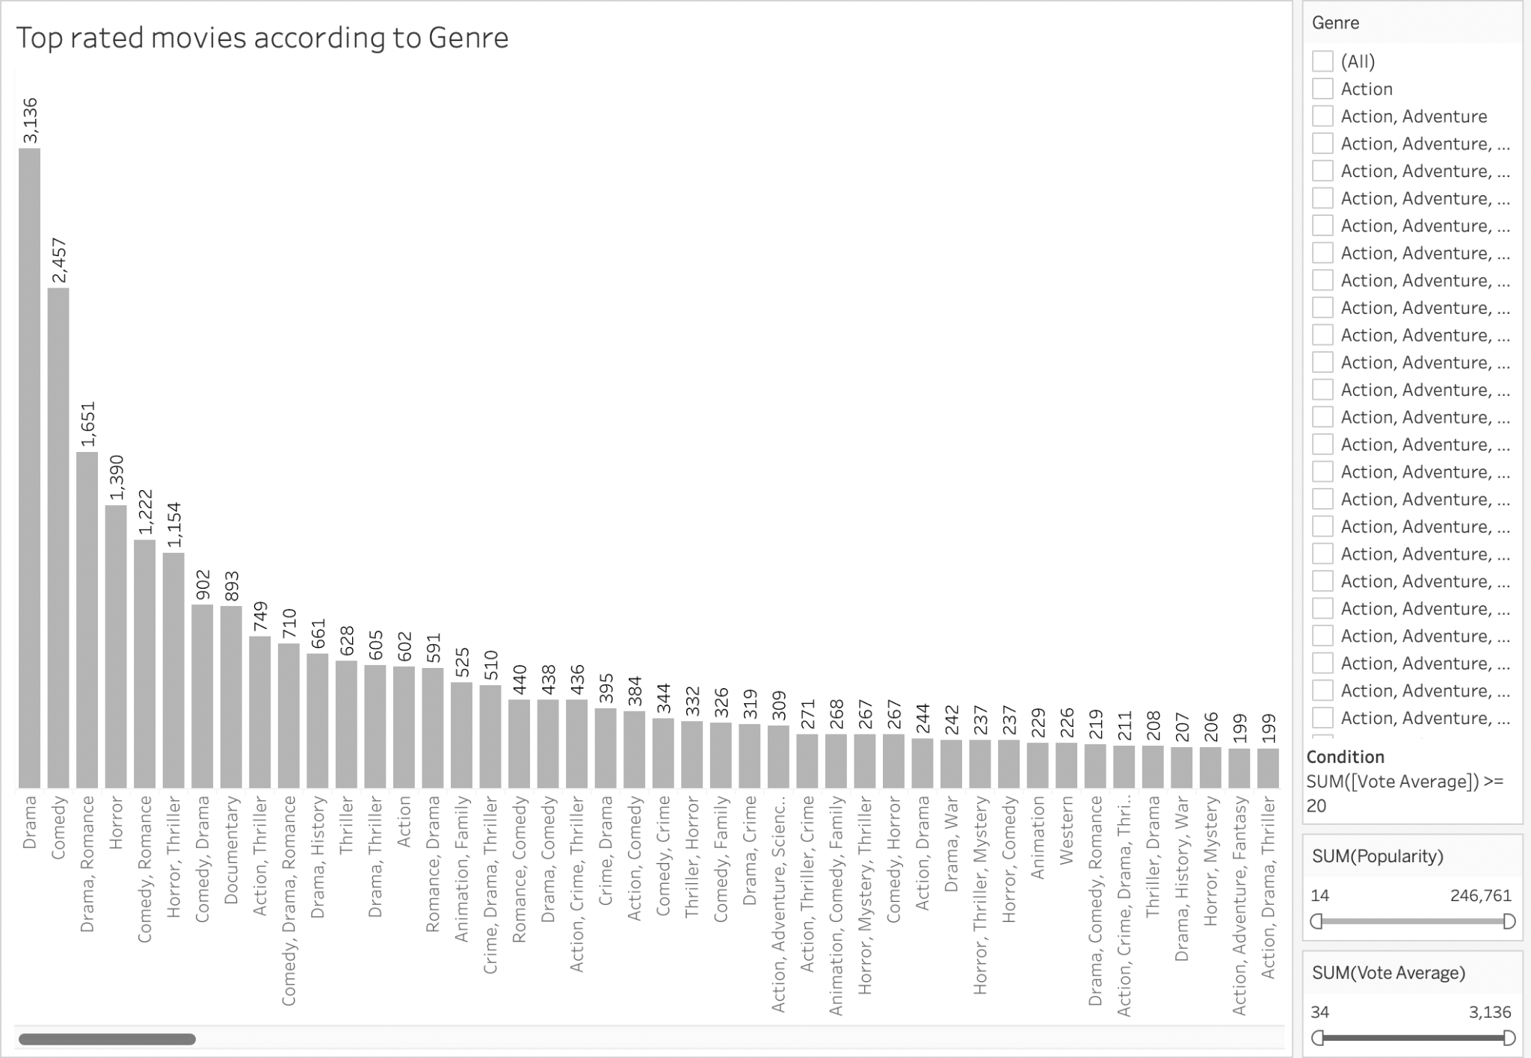

**Plot Explanation :** This plot explains which genre movies have top ratings. To create this visualization we are making use of vote average to determine top rating genre movies and also arranged the bar graph in a descending order from highest to lowest ratings.

**Pre-attentive attributes and Colors used:** The plot used here is bar chart and the pre-attentive attributes used are length and color used here is light gray.

**Plot 2 :**

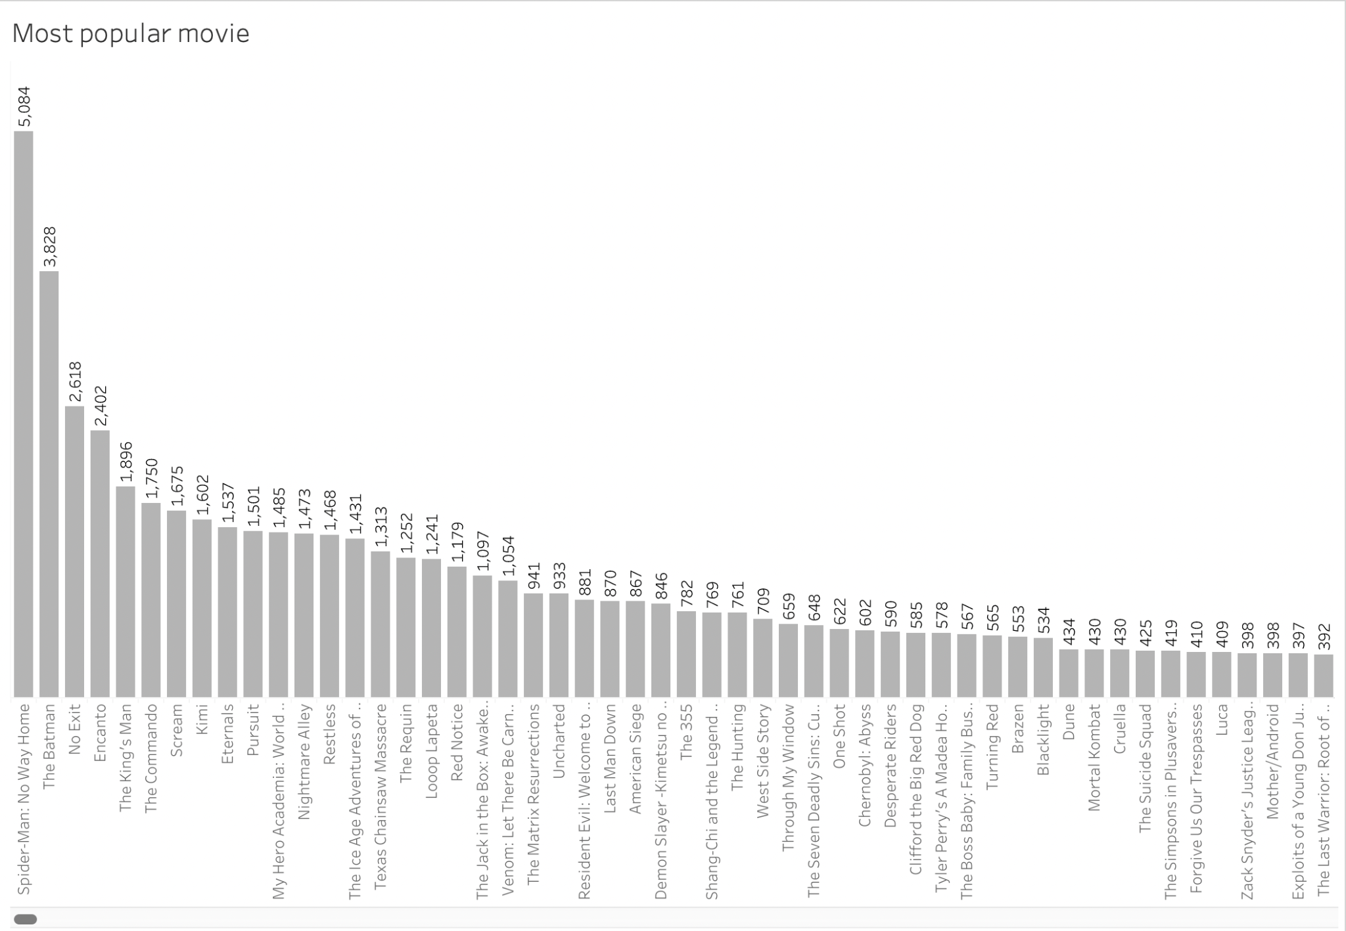

**Plot Explanation :** This plot helps to determine the most popular movie. To determine this we are making use of the popularity variable. Also, this bar graph is provided with the descending order to show which movie has the most popularity.

**Pre-attentive attributes and Colors used:** The plot used here is bar chart and the pre-attentive attributes used are length and color used here is light gray.

**Plot 3 :**

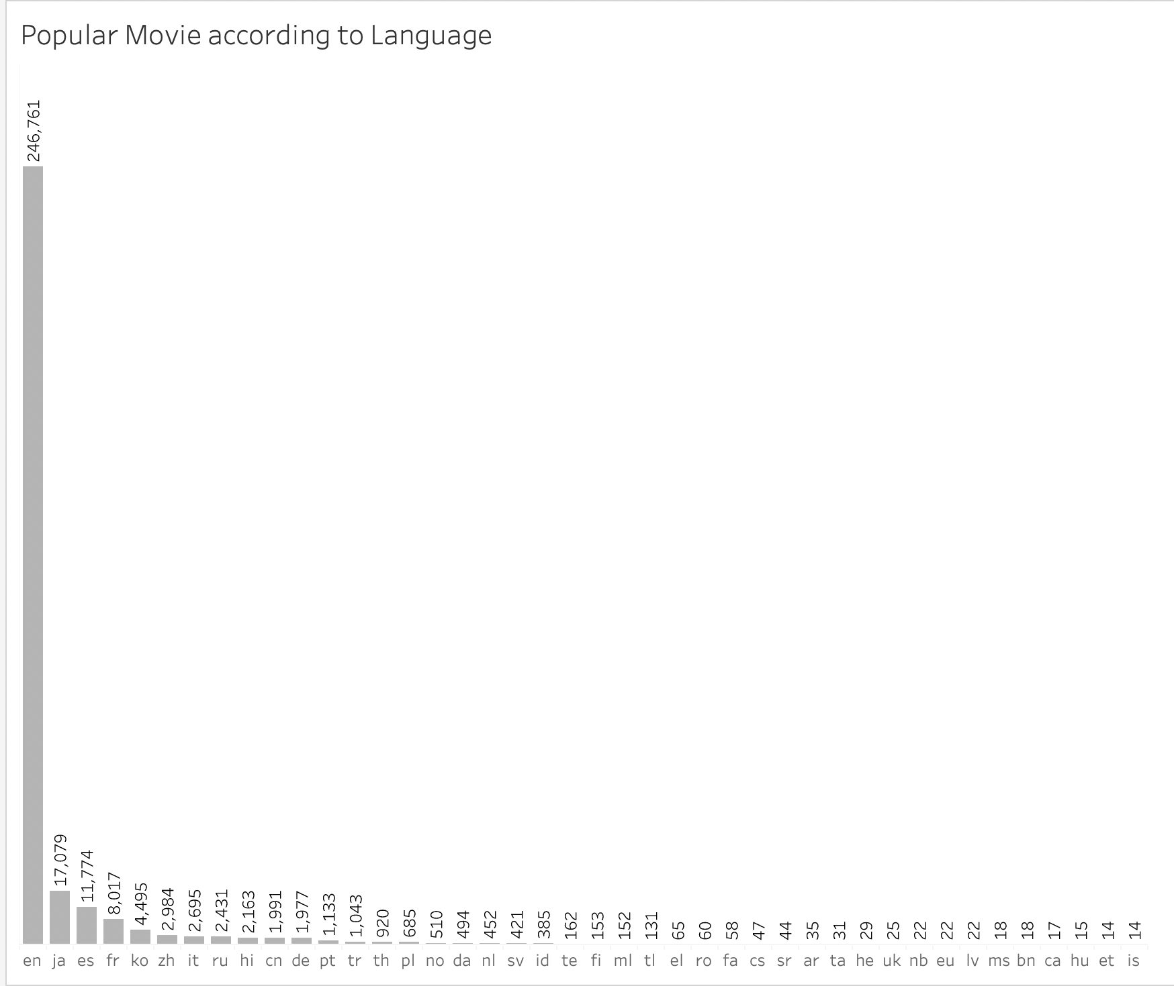

**Plot Explanation :** This bar chart shows which language movies have the most popularity. To show this, we are making use of the popularity variable and provided in the descending order to highlight that en language movies are most popular and we are making use of blue color in the chart to highlight the bars.

**Pre-attentive attributes and Colors used:** The plot used here is bar chart and the pre-attentive attributes used are length and color used here is light gray.

**Plot 4:**

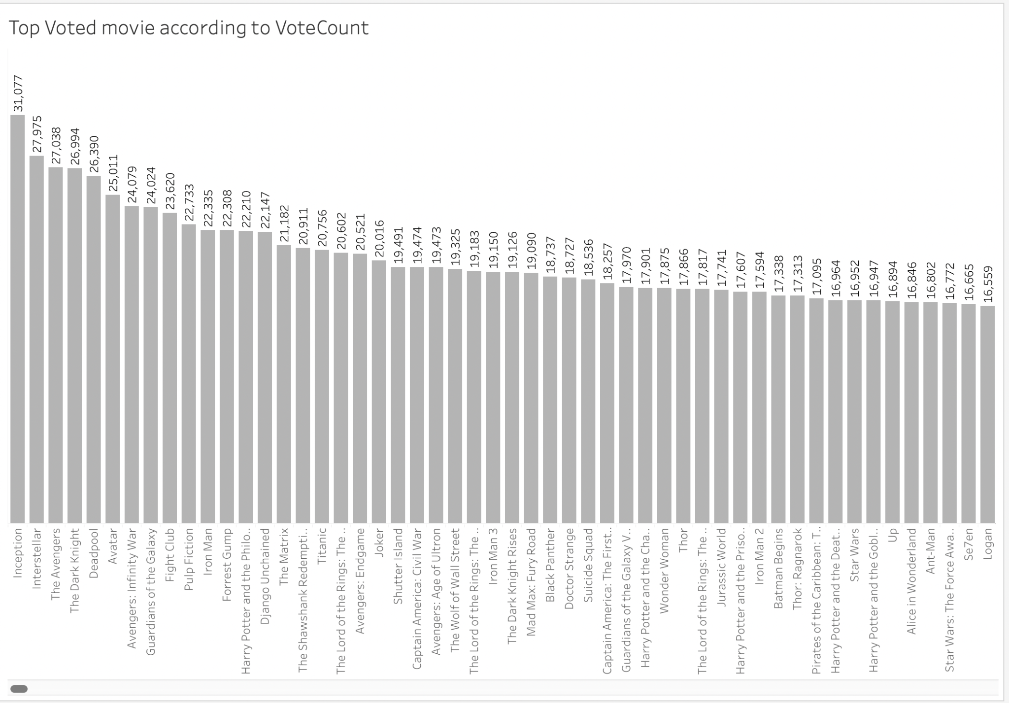

**Plot Explanation :** This graph is used to represent the movie that has top votings. To determine this we are making use of the vote count variable. Also, this bar graph is provided with the descending order to show which movie has the most votes.

**Pre-attentive attributes and Colors used:** The plot used here is bar chart and the pre-attentive attributes used are length and color used here is light gray.

**Plot 5:**

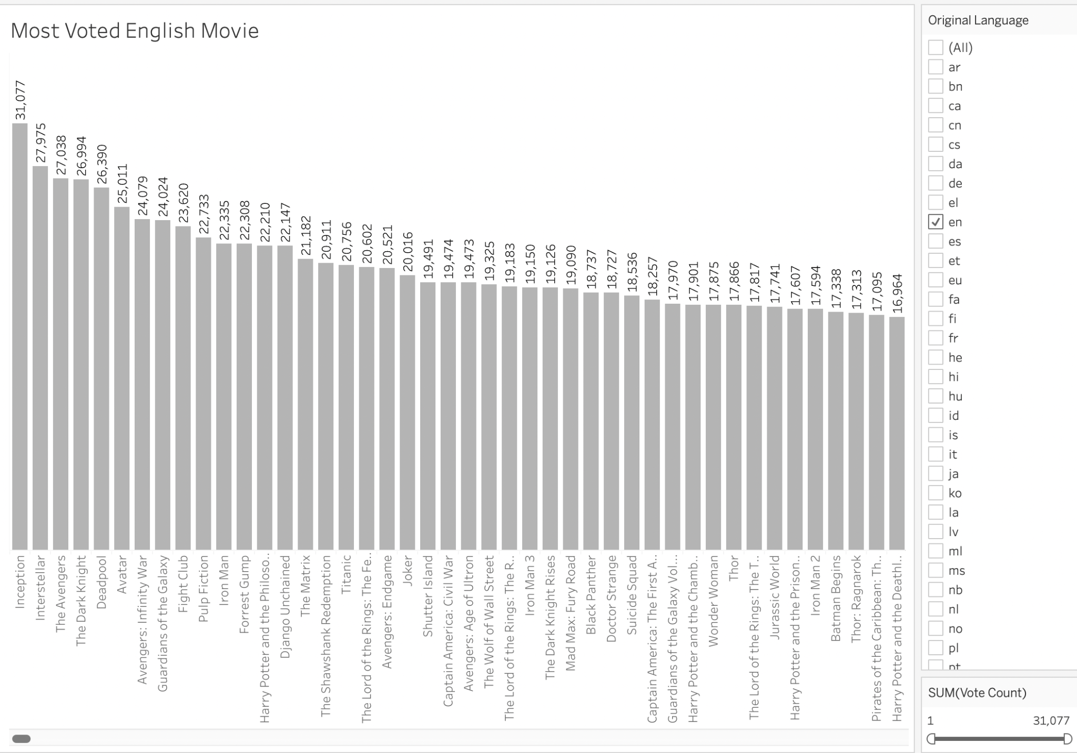

**Plot Explanation :** The below graph shows the most voted English language movie. To determine this factor we are making use of titles on x-axis and vote count on y-axis. Also, we are making use of a filter which is the original language variable choosing only English language(en) for this bar graph.

**Pre-attentive attributes and Colors used:** The plot used here is bar chart and the pre-attentive attributes used are length and color used here is light gray.

**Plot 6:**

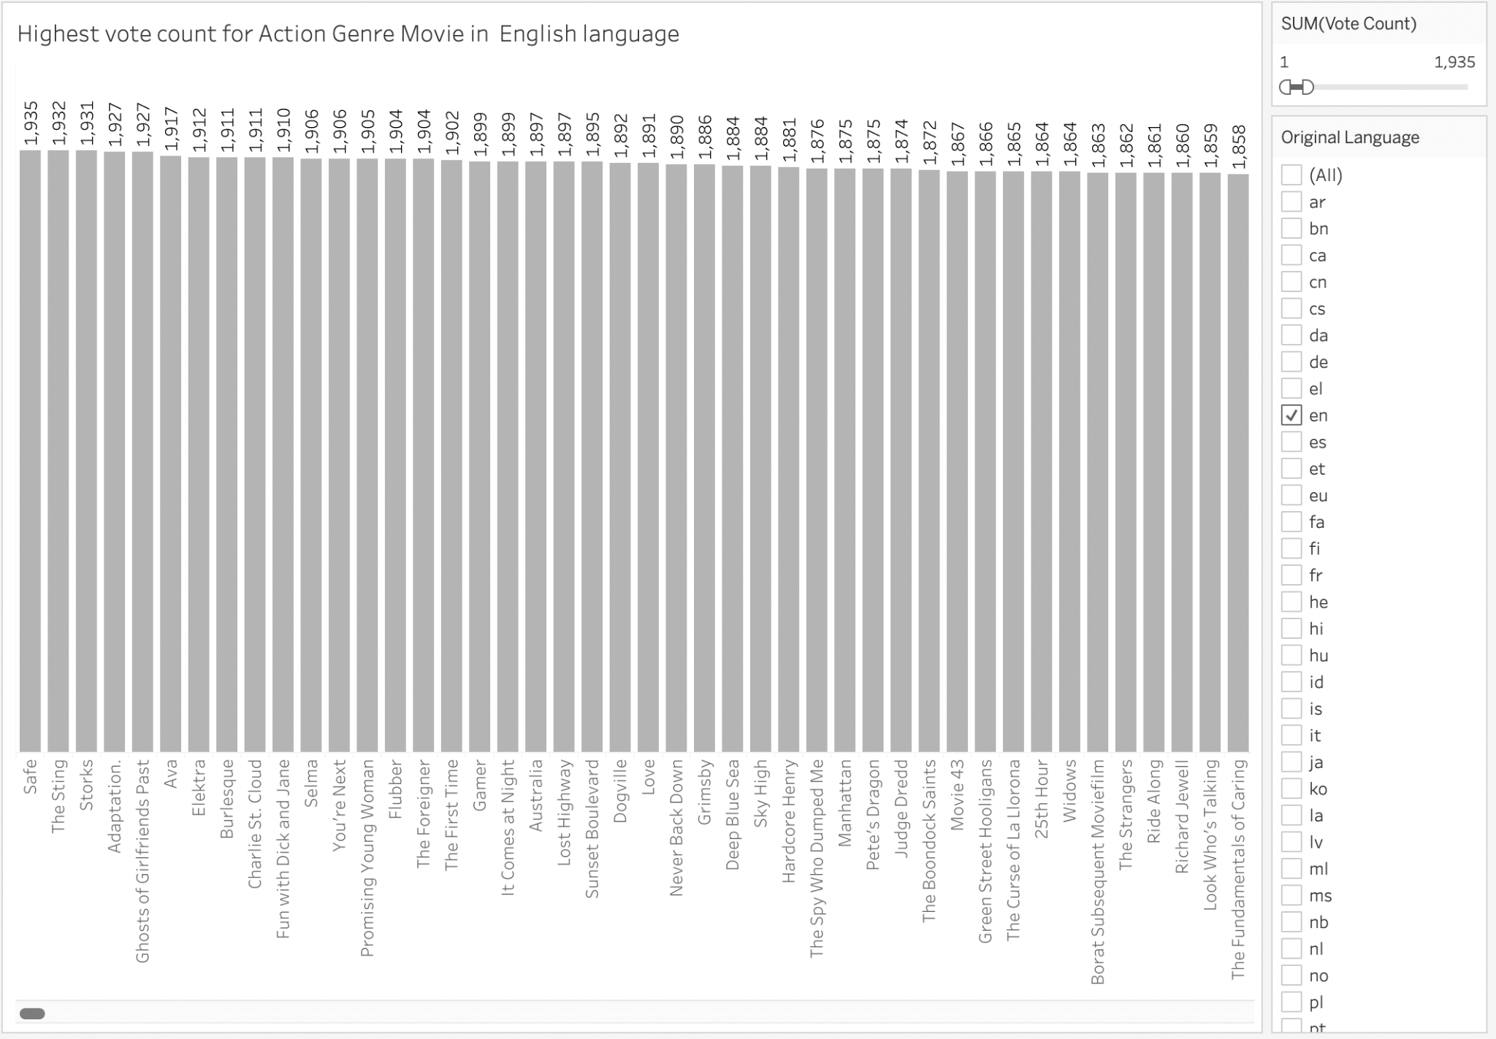

**Plot Explanation :** The below bar graph determines which movie has the highest vote count for the action genre in English language. To determine this factor we are making use of titles on x-axis and vote count on y-axis. Additionally, we are making use of two filters, which is the original language variable choosing only English language(en) and the second filter is genre choosing only action.

**Pre-attentive attributes and Colors used:** The plot used here is bar chart and the pre-attentive attributes used are length and color used here is light gray.

**Plot 7:**

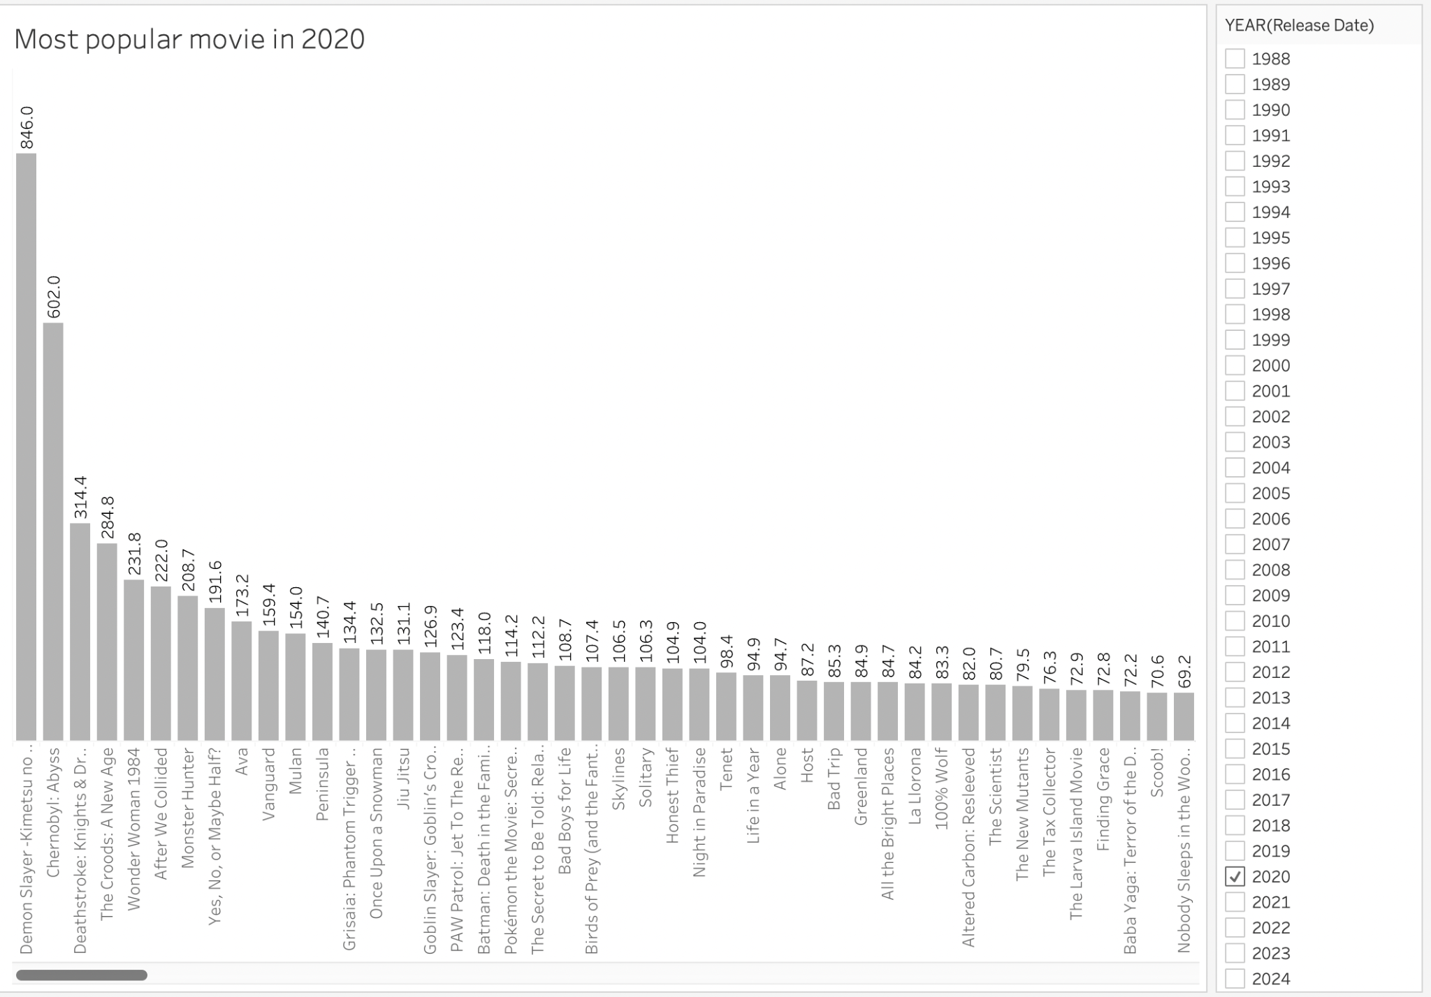

**Plot Explanation :** This plot helps to determine the most popular movie in the year 2020. To determine this we are making use of the popularity variable. Here, we are making use of the filter which is the year and we select the year 2020 so that the graph only highlights the movies from the year 2020 only. Also, this bar graph is provided with the descending order to show which movie has the most popularity.

**Pre-attentive attributes and Colors used:** The plot used here is bar chart and the pre-attentive attributes used are length and color used here is light gray.

**Plot 8:**

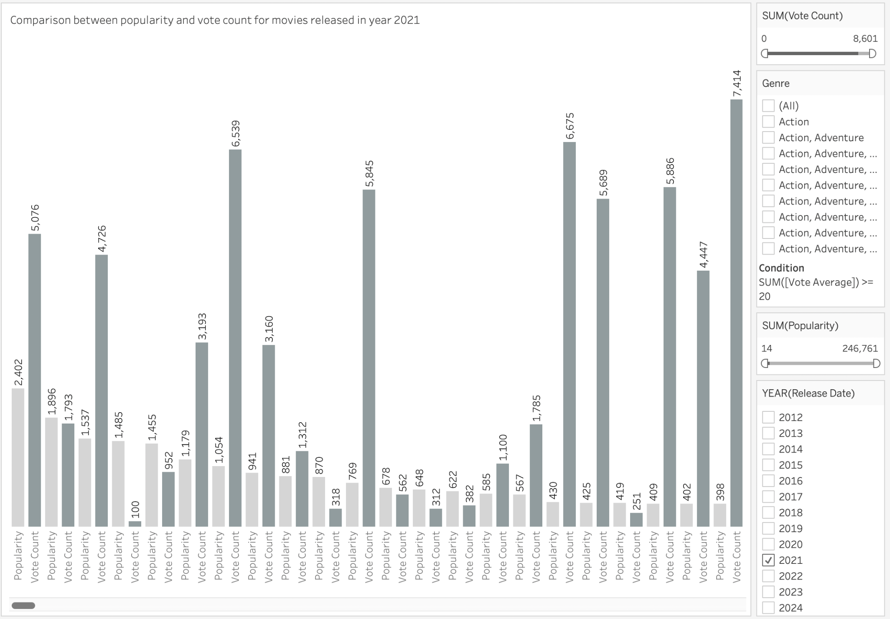

**Plot Explanation :** This graph shows the comparison between popularity and vote count for each movie released in the year 2020. Here we are using popularity and vote count and each has different colors to show the contrast between those two variables.

**Pre-attentive attributes and Colors used:** The plot used here is bar chart and the pre-attentive attributes used are length and color used here is light gray and gray to show the differentiation between popularity and vote count.

**Plot 9:**

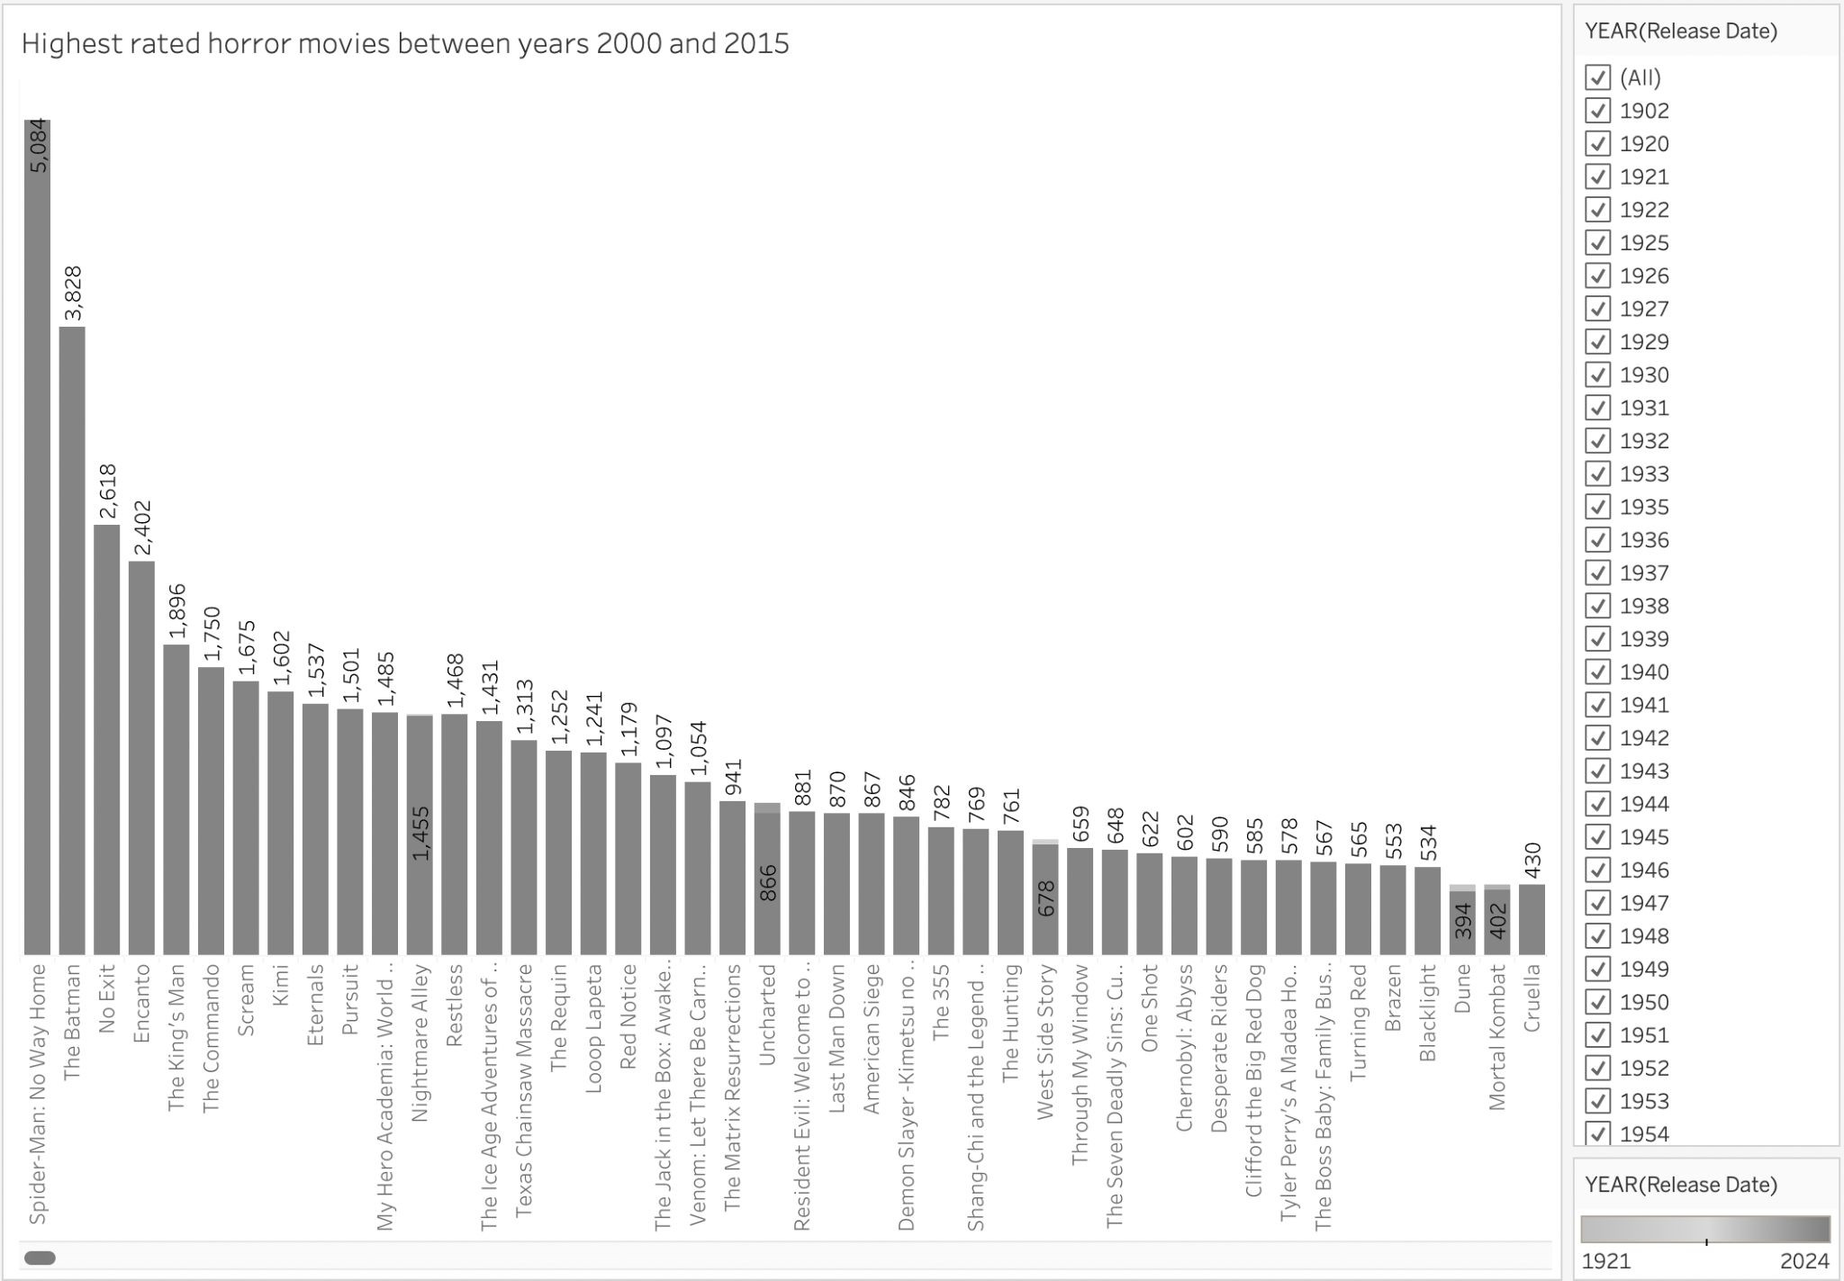

**Plot Explanation :** This plot represents the horror movies which are popular between 2000 to 2015. We are making use of the filter which is year to select the years 2000 to 2015 and genre to select the horror movies only.

**Pre-attentive attributes and Colors used:** The plot used here is a bar chart and the pre-attentive attributes used are length and gray color palette are used in this plot to display each year distinctively.

**Plot 10:**

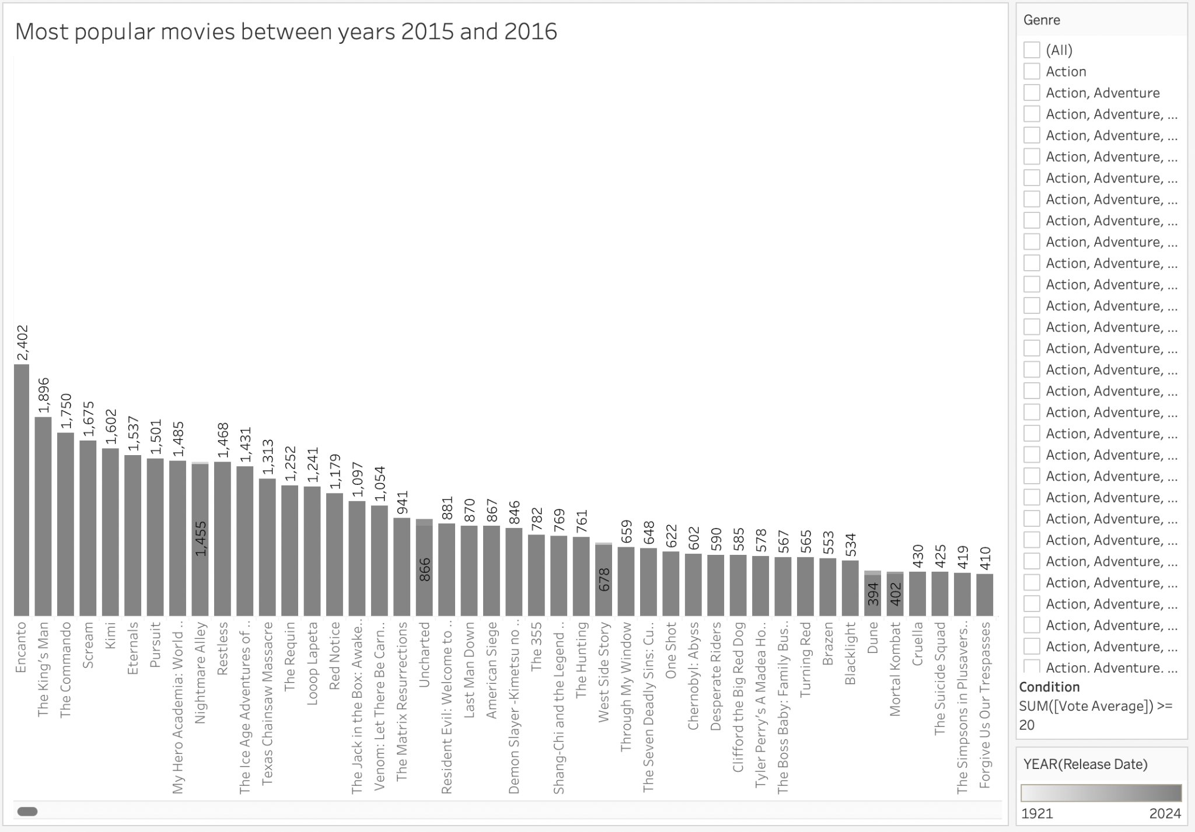

**Plot Explanation :** This plot displays the movies which are popular between 2015 and 2016. In this plot x-axis represents the movies and y-axis represents the count of popularity.

**Pre-attentive attributes and Colors used:** The plot used here is bar chart and the pre-attentive attributes used are length and color used here is light gray and gray which resembles the years 2015 and 2016.

**Section 6: Interactivity**

For dashboard control and user interactivity, we have added a genre filter and original language filter for the user to select any particular or more than one genre or language to display the plots.

Top-n-popularity filter: It displays the popularity of movies in the selected range.

Pre-attentive attributes: We have used length,color as attributes to present the highlights or movies based on the questions.

The dash board will have some parameters where users can use them to see the detailed information about the plots.

We have used different pre-attentive attributes to remove chatjunks.